I.INTRODUCTION
The Demand for renewable energy has increased significantly over the years because of shortage fossil fuels and greenhouse effect. The definition of renewable energy includes any type of energy generated from natural resources that is infinite or constantly renewed. Examples of renewable energy include solar, wind, and hydropower. Renewable energy, due to its free availability and its clean and renewable character, ranks as the most promising renewable energy resources like Solar energy, Wind energy that could play a key role in solving the worldwide energy crisis. Among various types of renewable energy sources, solar energy and wind energy have become very popular and demanding due to advancement in power electronics techniques. Photovoltaic (PV) sources are used today in many applications as they have the advantages of effective maintenance and pollution free.
Renewable energy is currently widely used. One of these resources is solar energy. The photovoltaic (PV) array normally uses a maximum power point tracking (MPPT) technique to continuously deliver the highest power to the load when there are variations in irradiation and temperature. The disadvantage of PV energy is that the PV output power depends on weather.
Solar electric energy demand has grown consistently by 20% to 25% per annum over the past 20 years, which is mainly due to its decreasing costs and prices. This decline has been driven by the following factors.
1) An increasing efficiency of solar cells
2) Manufacturing technology improvements
3) Economies of scale.

II. OVERVIEW
2.1 Single line diagram 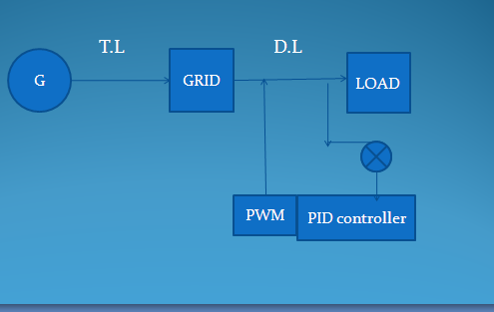

From the single line diagram, the power generated at the generating station can be supplied to various loads. In the final stage of power transmission the quality of power is drastrically reducing. Therefore improvement in the quality of power is done by employing PID Controllers using Pulse Width Modulation technique.
2.2 Principle
Because PV arrays are used as input voltage sources, the voltage produced by the arrays is known as V arrays. V arrays boosted by a dc–dc boost converter to exceed √2Vg. The voltage across the dc-bus capacitors is known as V pv. The operational principle of the proposed inverter is to generate five level output voltage, i.e., 0, +V p v/2, +Vpv, −Vpv/2, and –V pv. Proper switching control of the auxiliary circuit can generate half level of PV .supply voltage, i.e., +V pv/2 and –V p v/2.
Two reference signals Vref1 and Vref2 will take turns to be compared with the carrier signal at a time. If Vref1 exceeds the peak amplitude of the carrier signal V carrier, Vref2 will be compared with the carrier signal until it reaches zero. At this point onward,Vref1 takes over the comparison process until it exceeds V carrier.

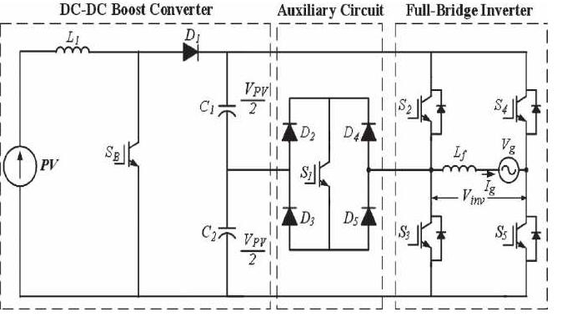
Fig.2 single phase five level inverter topology

III.INVERTERS
D.C-A.C. inverters are electronic devices used to produce mains voltage A.C. power from low voltage D.C. energy (from a battery or solar panel). This makes them very suitable for when you need to use A.C. power tools or appliances but the usual A.C. mains power is not available. Examples include operating appliances in caravans and mobile homes, and also running audio, video and computing equipment in remote areas. Most inverters do their job by performing two main functions: first they convert the incoming D.C. into A.C., and then they step up the resulting A.C. to mains voltage level using a transformer. And the goal of the designer is to have the inverter perform these functions as efficiently as possible so that as much as possible of the energy drawn from the battery or solar panel is converted into mains voltage A.C., and as little as possible is wasted as heat.
Square-wave or quasi- wave voltages may be acceptable for low and medium power applications, and for high applications low-distorted , sinusoidal waveforms are required .The output frequency of an inverter is determined by the rate at which the semi conductor devices are switched on and off by the inverter control circuitry and consequently, an adjustable frequency A.C. output is readily provided .The harmonic contents of output voltage can be minimized or reduced significantly by switching techniques of available high speed power semiconductor devices The D.C. power to the inverter may be battery, fuel cell ,solar cells or other D.C. source .But in most industrial applications it is fed by rectifier. This configuration of A.C. to D.C. converter and D.C. to A.C. inverter is called a D.C. link.
Inverters can be classified on the basis of a number of factors:
  - Classification Based On Nature Of Input Source
- Voltage Source Inverters(VSI)
- Current Source Inverters(CSI)
In case of VSI, the input to the inverter is provided by a ripple free dc voltage source and the dc source has small or negligible impedance .Because of low internal impedance, the terminal of a voltage source inverter remains substantially constant with variations in load. Any short circuit across its terminals causes current to rise fast, due to low time constant of its internal impedance. It is therefore, equally suitable for single and multi- motor drives.
On the other hand, CSI is supplied with a controlled current from a D.C. source of high impedance. Typically, a phase controller rectifier feeds the inverter with a regulated current through a large series inductor. Inverter output voltage is dependent upon the load impedance. Because of a large internal impedance, the terminal voltage of a current source inverter changes substantially with a change in load. Therefore it is not suitable for single and multi-motor drives.
  - Classification based on Waveshape of output
- Square-wave Inverter
- Pulse-width modulated(PWM) Inverter
A square-wave inverter produces a square ac voltage of a constant magnitude. The output voltage of this type of inverter can only be varied by controlling the input dc voltage. Square-wave ac output voltage of an inverter is adequate for low and medium power applications. The second method, pulse width modulation (PWM) uses a switching scheme within the inverter to modify the shape of the output voltage waveform
3.3 Topologies for Multilevel Inverter
There are three different major multilevel converter structures which have been applied in industrial applications:
- Diode-Clamped Multilevel Inverter
- Cascaded H-bridges converter with separate dc sources
- Flying Capacitor Multilevel Inverter
Proposed topology
3.3.1 Diode clamped Inverter
The most commonly used multilevel topology is the diode clamped inverter in which the diode is used as the clamping device to clamp the dc bus voltage so as to achieve steps in the output voltage. Figures 3.1 and 3.2 show the circuit for a diode clamped inverter for a three-level and a five-level inverter. The key difference between the two-level inverter and the three-level inverter are the diodes D1a and D2a. These two devices clamp the switch voltage to half the level of the DC bus voltage. In general the voltage across each capacitor for an m-level diode clamped inverter at steady state is V dc/ m-1. Although each active switching device is only required to block V dc/ m-1, the clamping devices have different ratings.
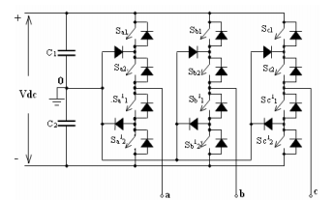
Fig.3.1 Three phase three-level DCMLI
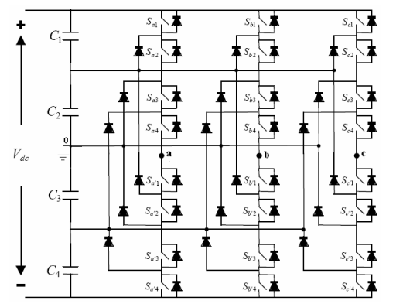
. Fig.3.2 Three-phase five-level DCMLI.
A three-phase five-level diode-clamped inverter is shown in Figure.3.2. In this circuit, the dc bus voltage is split in to five levels by four series connected bulk capacitors C1, C2, C3 and C4. For a dc bus voltage V dc , the voltage across each capacitor is V dc /4, and each device voltage stress will be limited to one capacitor voltage level, V dc/ 4, through clamping diodes.
Advantages:
- All of the phases share a common dc bus, which minimizes the capacitance requirements of the converter. For this reason, a back-to-back topology is not only possible but also practical for uses such as a high-voltage back-to-back inter-connection or an adjustable speed drive.
- The capacitors can be pre-charged as a group.
- Efficiency is high for fundamental frequency switching.
Disadvantages:
- The number of clamping diodes required is quadratically related to the number of levels, which can be cumbersome for units with a high number of level
- Real power flow is difficult for a single inverter because the intermediate dc levels will tend to overcharge or discharge without precise monitoring and control.
3.3.2 Cascaded H-Bridge Inverter
The cascaded converter has several attractive features. One such feature is that the cascaded converter can be easily controlled to mitigate the charge-balancing problems that plague many multilevel-converter topologies. A charge imbalance originates from the uneven charging and discharging of multiple dc sources at different voltage levels, causing a voltage imbalance.
A dc voltage imbalance will degrade the quality of the voltage output; in severe cases, this could lead to the complete collapse of the power-conversion system. The output voltage is a staircase waveform synthesized by alternating the contributions of multiple H-bridges at each half-cycle.
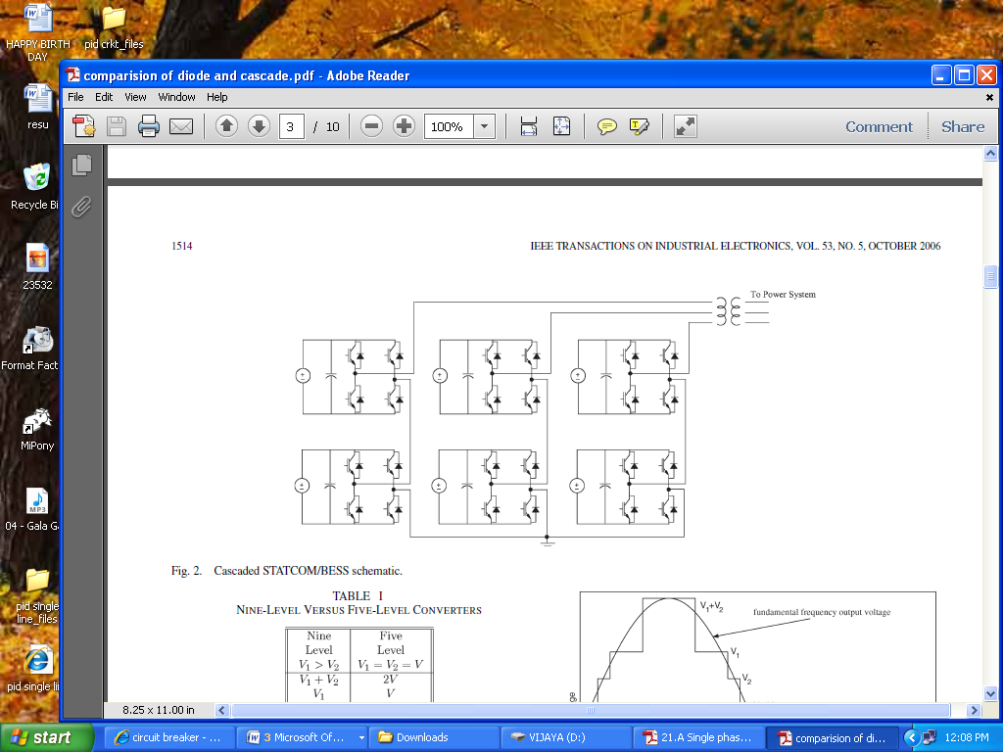
Fig.3.3 Three Phase Cascaded H-Bridge Inverter
Advantages:
- Real power flow is difficult for a single inverter because the intermediate dc levels will tend to overcharge or discharge without precise monitoring and control.
Disadvantages:
Separate dc sources are required for each of the H-bridges. This will limit its application to products that already have multiple SDCSs readily available.
3.3.3 CAPACITOR CLAMPED
The structure of this inverter is similar to that of the diode-clamped inverter except that instead of using clamping diodes, the inverter uses capacitors in their place. The circuit topology of the flying capacitor multilevel inverter is shown in Figure 3.4. This topology has a ladder structure of dc side capacitors, where the voltage on each capacitor differs from that of the next capacitor. The voltage increment between two adjacent capacitor legs gives the size of the voltage steps in the output waveform.

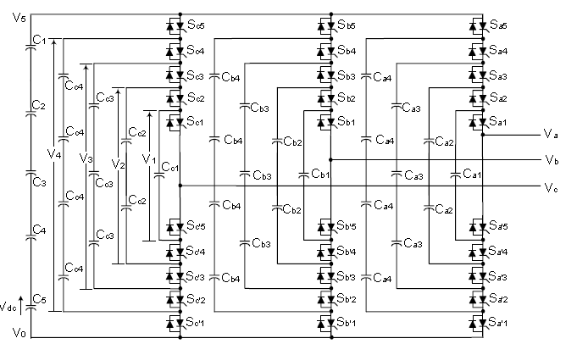
Fig.3.4 Three-phase six-level structure of a flying capacitor inverter
Advantages:
- The large number of capacitors enables the inverter to ride through short duration outages and deep voltage sags.
- Phase redundancies are available for balancing the voltage levels of the capacitors.
- Real and reactive power flow can be controlled.
Disadvantages:
- Control is complicated to track the voltage levels for all of the capacitors. Also, pre charging all of the capacitors to the same voltage level and startup are complex.
- Switching utilization and efficiency are poor for real power transmission.
- The large numbers of capacitors are both more expensive and bulky than clamping diodes in multilevel diode-clamped converters. Packaging is also more difficult in inverters with a high number of level.
IV.PHOTOVOLTAIC SYSTEM
4.1 History and Architecture
The development of the solar cell stems from the work of the French physicist Antoine-César Becquerel in1839.He discovered the photovoltaic effect while experimenting with a solid electrode in an electrolyte solution; he observed that the voltage developed when light fell upon the electrode. About 50 years later, Charles Fritts constructed the first true solar cells using junctions formed by coating the selenium, a semiconductor with an ultrathin, nearly transparent layer of gold. Fritts's devices were very inefficient, transforming less than 1 percent of the absorbed light into electrical energy.
By 1927 another metal semiconductor-junction solar cell, in this case made of copper and the semiconductor copper oxide, had been demonstrated. By the 1930s both the selenium cell and the copper oxide cell were being employed in light-sensitive devices, such as photometers, for use in photography. These early solar cells, however, still had energy-conversion efficiencies of less than 1 percent. This impasse was finally overcome with the development of the silicon solar cell by Russell in 1941. In 1954, three other American researchers, G.L. Pearson, Daryl Chapin, and Calvin Fuller, demonstrated a silicon solar cell capable of a 6-percent energy-conversion efficiency when used in direct sunlight. By the late 1980s silicon cells, as well as those made of gallium arsenide, with efficiencies of more than 20 percent had been fabricated. In 1989 a concentrator solar cell, a type of device in which sunlight is concentrated onto the cell surface by means of lenses, achieved an efficiency of 37 percent due to the increased intensity of the collected energy. In general, solar cells of widely varying efficiencies and cost are now available.
The origin of the PV potential is the difference in the chemical potential, called the Fermi level, of the electrons in the two isolated materials. When they are joined, the junction approaches a new thermodynamic equilibrium. Such equilibrium can be achieved only when the Fermi level is equal in the two materials. This occurs by the flow of electrons from one material to the other until a voltage difference is established between them, which have a potential just equal to the initial difference of the Fermi level. This potential drives the photocurrent in the pv circuit.

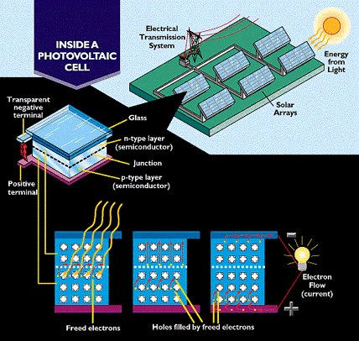
Fig.4.1 Model of Photo voltaic system
Photo voltaics is the field of technology and research related to the practical application of photovoltaic cells in producing electricity from light, though it is often used specifically to refer to the generation of electricity from sunlight

Fig.4.2 Basic construction of PV cell
The diagram above illustrates the operation of a basic photovoltaic cell, also called a solar cell. Solar cells are made of the same kinds of semiconductor materials used in microelectronics, such as silicon (melted sand) or cadmium telluride. For solar cells, a thin semiconductor wafer is specially treated to form an electric field, positive on one side and negative on the other. When light energy strikes the solar cell, electrons are knocked loose from the atoms in the semiconductor material. If electrical conductors are attached to the positive and negative sides, forming an electrical circuit, the electrons can be captured in the form of an electric current. This electricity can then be used to power a load, such as a light or a tool. Each PV cell converts about 5 to 15 percent of the sunlight that hits it into electrical current. Photovoltaic cells are modular. That is, one can be used to make a very small amount of electricity, or many can be used together to make a large amount of electricity.
Photovoltaic cell produces only about one-half volt of electricity, cells are often mounted together in groups called modules. Each module holds about forty photovoltaic cells. By being put into modules, the current from a number of cells can be combined. PV cells can be strung together in a series of modules or strung together in a parallel placement to increase the electrical output
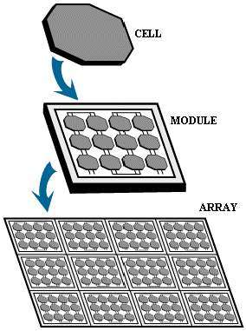

Fig.4.3 The PV array set up
When multiple PV cell modules are put together, they can form an arrangement called an array or array field. In general, the larger the area of a module or array, the more electricity that will be produced. Photovoltaic modules and arrays produce direct current (dc) electricity. They can be connected in both series and parallel electrical arrangements to produce any required voltage and current combination.
4.2Photovoltaic Effect
Photovoltaic (PV) is a method of generating electrical power by converting solar radiation into direct current electricity using semiconductors that exhibit the photovoltaic effect. Photovoltaic power generation employs solar panels comprising a number of cells containing a photovoltaic material. Materials presently used for photovoltaic include mono crystalline silicon, polycrystalline silicon, amorphous silicon, cadmium telluride, and copper indium selenide /sulfide.[1] Due to the growing demand for renewable energy sources, the manufacturing of solar cells and photovoltaic arrays has advanced considerably in recent years.
As of 2010, solar photovoltaic generates electricity in more than 100 countries and, while yet comprising a tiny fraction of the 4800 GW total global power-generating capacity from all sources, is the fastest growing power-generation technology in the world.
Between 2004 and 2009, Grid-connected PV capacity increased at an annual average rate of 60 percent, to some 21 GW. Such installations may be ground-mounted (and sometimes integrated with farming and grazing) or built into the roof or walls of a building, known as Building Integrated Photovoltaic’s or BIPV for short. Off-grid PV accounts for an additional 3–4 GW. Driven by advances in technology and increases in manufacturing scale and sophistication, the cost of photovoltaic has declined steadily since the first solar cells were manufactured. Net metering and financial incentives, such as preferential feed-in tariffs for solar-generated electricity; have supported solar PV installations in many countries.
The photovoltaic effect is the generation of a voltage (or a corresponding electric current) in a material upon exposure to light. Though the photovoltaic effect is directly related to the photoelectric effect, the two processes are different and should be distinguished. In the photoelectric effect, electrons are ejected from a material's surface upon exposure to radiation of sufficient energy. The photovoltaic effect is different in that the generated electrons are transferred between different bands (i.e. from the valence to conduction bands) within the material, resulting in the buildup of a voltage between two electrodes. In most photovoltaic applications the radiation is sunlight and for this reason the devices are known as solar cells. In the case of a p-n junction solar cell, illumination of the material results in the generation of an electric current as excited electrons and the remaining holes are swept in different directions by the built-in electric field of the depletion region. The photovoltaic effect was first observed by Alexandre -Edmond Becquerel in 1839.
Fig.4.4 PV effect converts the photo

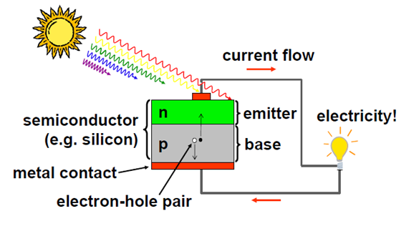

4.3 Performance and Characteristics of PV system
Temperature
Generally, temperatures above room temperature reduce the performance of photovoltaic

Optimum Orientation of Solar Panels
For best performance, terrestrial PV systems aim to maximize the time they face the sun. Solar trackers aim to achieve this by moving PV panels to follow the sun. The increase can be by as much as 20% in winter and by as much as 50% in summer. Static mounted systems can be optimized by analysis of the Sun path. Panels are often set to latitude tilt, an angle equal to the latitude, but performance can be improved by adjusting the angle for summer or winter.
Fig.4.5. Performance of maximum solar radiation of PV system

Irradiation
Irradiation is the process by which an item is exposed to radiation. The exposure can be intentional, sometimes to serve a specific purpose, or it can be accidental. In common usage the term refers specifically to ionizing radiation, and to a level of radiation that will serve that specific purpose, rather than radiation exposure to normal levels of background radiation or abnormal levels of radiation due to accidental exposure. This term also applies to 'non-ionizing radiation as microwaves or to low frequency (50/60 Hz power supply), high frequency (as cellular phones, radio and TV transmissions).

Insolation
Insolation is a measure of solar radiation energy received on a given surface area in a given time. It is commonly expressed as average irradiance in watts per square meter (W/m2) or kilowatt-hours per square meter per day (kW·h/(m²·day)) (or hours/day). In the case of photovoltaics it is commonly measured as kWh/(year/KW) (kilowatt hours per year per kilowatt peak rating).
The given surface may be a planet, or a terrestrial object inside the atmosphere of a planet, or any object exposed to solar rays outside of an atmosphere, including spacecraft. Some of the solar radiation will be absorbed while the remainder will be reflected. Most commonly, the absorbed solar radiation causes radiant heating, however, some systems may store or convert some portion of the absorbed radiation, as in the case of photovoltaics or plants. The proportion of radiation reflected or absorbed depends on the object's reflectivity , respectively.
Photovoltaic Park (Spain, 60 MW), the Strasskirchen Solar Park (Germany, 54 MW), the Lieberose Photovoltaic Park (Germany, 53 MW), the Puertollano Photovoltaic Park (Spain, 50 MW), the Moura photovoltaic power station (Portugal, 46 MW), and the Waldpolenz Solar Park (Germany, 40 MW).
Fig.4.6 PV cell equivalent circuit
The complex physics of the PV cell can be represented by the equivalent electrical circuit. The circuit parameters are as follows. The current I at the output terminals is equal to the light-generated current I_{L}, less the diode current I_{d} and the shunt-leakage current I_{sh}. The series resistance R_{s} represents the internal resistance to the current flow, and depends on the pn junction depth, impurities, and contact resistance. The shunt resistance R_{sh} is inversely related to the leakage current to ground. In an ideal PV cell, R_{s} = 0Ω (no series loss), and R_{sh} =∞(no leakage to ground). In a typical high-quality 1 in.2 silicon cell, Rs varies from 0.05 to 0.10 Ω and R_{sh} from 200 to 300 Ω. The PV conversion efficiency is sensitive to small variations in Rs, but is insensitive to variations in R_{sh}. A small increase in Rs can decrease the PV output significantly. In the equivalent circuit, the current delivered to the external load equals the current I_{L} generated by the illumination, less the diode current Id and the shunt leakage current I_{sh}. The open-circuit voltage Voc of the cell is obtained when the load current is zero, i.e., when I = 0, and is given by the following:
V_{oc}=V+I R _{sh}
The shunt resistance (R_{sh}) is very large and the series resistance (Rs) is very small. Therefore, it is common to neglect these resistances in order to simplify the solar cell model. The resultant ideal voltage-current characteristic of a photovoltaic cell is given by the relation below and illustrated by the figure above.
I=I_{ph}-I_{D}
I=I_{ph}-I₀$\left[exp\left(\frac{q\left(V+R_{s}I\right)}{Ak_{B}T}\right)-1\right]-\frac{V+R_{s}I}{R_{sh}}$
Where,
I_{ph} = photocurrent,
I_{D} = diode current,
I₀ = saturation current,
A = ideality factor,
q = electronic charge 1.6x10⁻⁹,
k_{B} = Boltzmann’s gas constant (1.38x10⁻²³),
T = cell temperature,
R_{s} = series resistance,
R_{sh} = shunt resistance,
I = cell current,
I_{ph} = photocurrent,
I_{D} = diode current,
I₀ = saturation current,
A = ideality factor,
q = electronic charge 1.6x10⁻⁹,
k_{B} = Boltzmann’s gas constant (1.38x10⁻²³),
T = cell temperature,
R_{s} = series resistance,
R_{sh} = shunt resistance,
I = cell current,
The power output of a solar cell is given by
P_{PV} = V_{PV} * I_{PV}
Where,
I_{PV} = Output current of solar cell (A).
V_{PV} = Solar cell operating voltage (V).
P_{PV} =Output power of solar cell (W).
The power-voltage (P-V) characteristic of a photovoltaic module operating at a standard irradiance of 1000 W/m² and temperature of 25ºC is shown below.

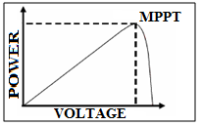
Fig.4.7 Power-Voltage Characteristics of a Photovoltaic Module.
It can be seen from the characteristics, that there is a unique point on the characteristics at which the photovoltaic power is maximum. This point is termed as the maximum power point (MPP). The power corresponding to this point is termed as power at maximum power point (P_{mpp}) and the voltage as voltage at maximum power point (V_{mpp}). Due to high cost of solar cells, it must be ensured that the photovoltaic array operates at all time to provide maximum power output. Hence a maximum power point tracker must be used to track the maximum power of the system. This is commonly known as maximum power point tracking (MPPT). Now if the irradiance level of the photovoltaic system is changed from the standard 1000 W/m² to say 600 W/m² or 400 W/m² then the P-V characteristic will change as shown in the figure below.
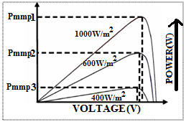

Fig.4.8 Variation of P-V Characteristics of Photovoltaic Module
The above fig.4.8shows that, the maximum power of the PV system also reduces accordingly. The maximum power point tracker must now track the new maximum power point for the changed irradiance level.

Electrical Connection of the Cells
The electrical output of a single cell is dependent on the design of the device and the Semi-conductor material(s) chosen, but is usually insufficient for most applications. In order to provide the appropriate quantity of electrical power, a number of cells must be electrically connected. There are two basic connection methods: series connection, in which the top contact of each cell is connected to the back contact of the next cell in the sequence, and parallel connection, in which all the top contacts are connected together, as are all the bottom contacts. In both cases, this results in just two electrical connection points for the group of cells.
- Series connection
Figure4.9 shows the series connection of three individual cells as an example and the resultant group of connected cells is commonly referred to as a series string. The current output of the string is equivalent to the current of a single cell, but the voltage output is increased, being an addition of the voltages from all the cells in the string (i.e. in this case, the voltage output is equal to 3Vcell).
Fig.4.9 Series connection of cells with resulting current–voltage characteristics.
It is important to have well matched cells in the series string, particularly with respect to current. If one cell produces a significantly lower current than the other cells (under the same illumination conditions), then the string will operate at that lower current level and the remaining cells will not be operating at their maximum power points.

- Parallel connection
Figure4.10 shows the parallel connection of three individual cells as an example. In this case, the current from the cell group is equivalent to the addition of the current from each cell, but the voltage remains equivalent to that of a single cell.
As before, it is important to have the cells well matched in order to gain maximum output, but this time the voltage is the important parameter since all cells must be at the same operating voltage. If the voltage at the maximum power point is substantially different for one of the cells, then this will force all the cells to operate off their maximum power point, with the poorer cell being pushed towards its open-circuit voltage value and the better cells to voltages below the maximum power point voltage. In all cases, the power level will be reduced below the optimum.

Fig.4.10 Parallel connection of cells with resulting current–voltage characteristics.

4.4 Types of Photovoltaic Cells
A mono crystalline PV cell is blue or gray-black in color. At the rounded corner of each cell is a white backing. This backing shows through and makes a pattern that is easy to see. Some people do not use mono crystalline PV cells on their home or businesses because of their appearance. A module of PV cells is usually covered with tempered glass and surrounded by an aluminum frame.
A polycrystalline PV cell looks a little different than a mono crystalline PV cell. Polycrystalline PV cells are shaped like rectangles and colored sparkling blue. There is no white background showing. Thus, these PV cells look more uniform in appearance. Like mono crystalline cells, they are often covered in tempered glass and placed in an aluminum frame.
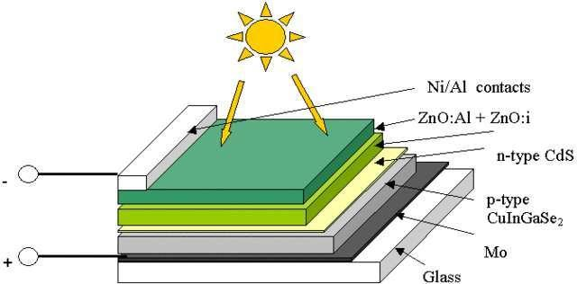

Fig.4.11 Structure of a model Solar Cell
Another type is the amorphous or thin-film cell. This type of PV cell is less durable and not as efficient for energy conversion. Thin-film cells are the future of PV cell technology because they use less semiconductor material, do not need as much energy to manufacture, and are easier to mass produce than other PV cells. Light weight and flexible, this technology can be weaved into the fabric of a building in applications where surface area is not an issue. Applications include building canopies, facades and rain screens. Solar panels use light energy (photons) from the sun to generate electricity through the photovoltaic effect. The structural (load carrying) member of a module can either be the top layer or the back layer (substrate). The majority of modules use wafer-based crystalline silicon cells or thin-film cells based on cadmium telluride or silicon.
Photovoltaics are also exceedingly versatile - the same technology that can pump water, grind grain and provide communications and village electrification in the developing world can produce electricity for the buildings and distribution grids of the industrialized countries.

Construction of PV module: (1) frame, (2) weatherproof junction box, (3) rating
plate, (4) weather protection for 30-yr life, (5) PV cell, (6) tempered high-transmittivity cover glass, (7) outside electrical bus, (8) frame clearance. (From Solarex/BP Solar, Frederick, MD.
4.5 Applications

In Buildings
Photovoltaic arrays are often associated with buildings: either integrated into them, mounted on them or mounted nearby on the ground.
Arrays are most often retrofitted into existing buildings, usually mounted on top of the existing roof structure or on the existing walls. Alternatively, an array can be located separately from the building but connected by cable to supply power for the building. In 2010, more than four-fifths of the 9,000 MW of solar PV operating in Germany was installed on rooftops.

In Transport
PV has traditionally been used for electric power in space. PV is rarely used to provide motive power in transport applications, but is being used increasingly to provide auxiliary power in boats and cars. A self-contained solar vehicle would have limited power and low utility, but a solar-charged vehicle would allow use of solar power for transportation. Solar-powered cars have been demonstrated.

Standalone Devices
Until a decade or so ago, PV was used frequently to power calculators and novelty devices. Improvements in integrated circuits and low power LCD displays make it possible to power such devices for several years between battery changes, making PV use less common. In contrast, solar powered remote fixed devices have seen increasing use recently in locations where significant connection cost makes grid power prohibitively expensive. Such applications include water pumps, parking meters, emergency telephones, trash compactors, temporary traffic signs, and remote guard posts & signals.

Rural Electrification
Developing countries where many villages are often more than five kilometers away from grid power have begun using photovoltaic. In remote locations in India a rural lighting program has been providing solar powered LED lighting to replace kerosene lamps. The solar powered lamps were sold at about the cost of a few months’ supply of kerosene. Cuba is working to provide solar power for areas that are off grid. These are areas where the social costs and benefits offer an excellent case for going solar though the lack of profitability could relegate such endeavors to humanitarian goals.

Solar roadways
A 45 mi (72 km) section of roadway in Idaho is being used to test the possibility of installing solar panels into the road surface, as roads are generally unobstructed to the sun and represent about the percentage of land area needed to replace other energy sources with solar power.

Solar Power Satellites
Design studies of large solar power collection satellites have been conducted for decades. The idea was first proposed by Peter Glaser, then of Arthur D. Little Inc; NASA conducted a long series of engineering and economic feasibility studies in the 1970s, and interest has revived in first years of the 21st century. From a practical economic viewpoint, the key issue for such satellites appears to be the launch cost. Additional considerations will include developing space based assembly techniques, but they seem to be less a hurdle than the capital cost. These will be reduced as photovoltaic cell costs are reduced or alternatively efficiency increased.
4.6 Solar Panel
A solar panel (photovoltaic module or photovoltaic panel) is a packaged interconnected assembly of solar cells, also known as photovoltaic cells. The solar panel can be used as a component of a larger photovoltaic system to generate and supply electricity in commercial and residential applications.
Because a single solar panel can only produce a limited amount of power, many installations contain several panels. This is known as a photovoltaic array. A photovoltaic installation typically includes an array of solar panels, an inverter, batteries and interconnection wiring. Photovoltaic systems are used for either on- or off-grid applications, and on spacecraft.
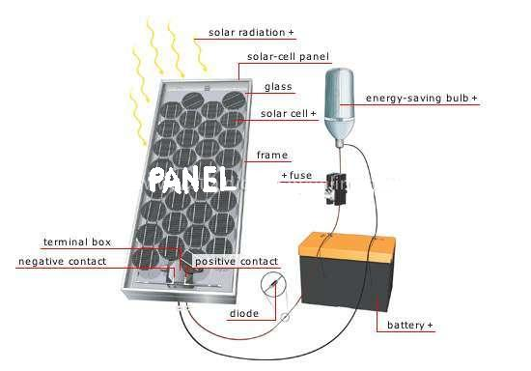
Fig.4.12 Solar Panel System

Working
Solar panels use light energy (photons) from the sun to generate electricity through the photovoltaic effect. The structural (load carrying) member of a module can either be the top layer (superstrate) or the back layer (substrate). The majority of modules use wafer-based crystalline silicon cells or thin-film cells based on cadmium telluride or silicon. Crystalline silicon is a commonly used semiconductor. In order to use the cells in practical applications, they must be: connected electrically to one another and to the rest of the system protected from mechanical damage during manufacture, transport, installation and use (in particular against hail impact, wind and snow loads). This is especially important for wafer-based silicon cells which are brittle protected from moisture, which corrodes metal contacts and interconnections, and for thin-film cells the transparent conductive oxide layer, thus decreasing performance and lifetime. Most solar panels are rigid, but semi-flexible ones are available, based on thin-film cells. Electrical connections are made in series to achieve a desired output voltage and/or in parallel to provide a desired amount of current source capability. Separate diodes may be needed to avoid reverse currents, in case of partial or total shading, and at night. The p-n junctions of mono-crystalline silicon cells may have adequate reverse current characteristics that these are not necessary. Reverse currents are not only inefficient as they represent power losses, but they can also lead to problematic heating of shaded cells. Solar cells become less efficient at higher temperatures and so it desirable to minimize heat in the panels. Very few modules incorporate any design features to decrease temperature, but installers try to provide good ventilation behind solar panels.

Solar Trackers
A solar tracker is a generic term used to describe devices that orient various payloads toward the sun. Payloads can be photovoltaic panels, reflectors, lenses or other optical devices.
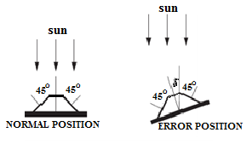
Fig.4.13 Sun-tracking actuator principle.
In standard photovoltaic (PV) applications trackers are used to minimize the angle of incidence between the incoming light and a photovoltaic panel. This increases the amount of energy produced from a fixed amount of installed power generating capacity.
Major Components Of A Solar Panel
Glass Cover- Provides protection from the elements .Anti-Reflective Coating - Substance used to prevent the light that strikes from bouncing off the panel. .Top Negative Contact - Negative Post (Terminal, like in your battery) .N-Type Layer - Semi-conductor layer dipped in phosphorus .P-Type Layer - Semi-conductor layer dipped in boron .Bottom Positive Contact - Positive Post (Terminal, like in a battery)
Open-Circuit Voltage and Short-Circuit Current
The two most important parameters widely used for describing cell electrical performance are the open-circuit voltage Voc and the short-circuit current I_{sc} under full illumination. The short-circuit current is measured by shorting the output terminals and measuring the terminal current. Ignoring the small diode and ground leakage currents under zero terminal voltage, the short-circuit current under this condition is the photocurrent IL.
Fig.4.14 Current vs. voltage (I-V) characteristic of the PV module in sunlight and in the dark.
The maximum photo voltage is produced under the open-circuit voltage. Again, by ignoring the ground leakage current, Equation 9.3 with I = 0 gives the open circuit voltage as follows:
V_{oc}=$\frac{AkT}{Q}{Log}_{n}\left(\frac{I_{L}}{I_{D}}+1\right)$
The term kT/Q is expressed in voltage (0.026 V at 300K). In practical photocells, the photocurrent is several orders of magnitude greater than the reverse saturation current. Therefore, the open-circuit voltage is many times the kT/Q value. Under conditions of constant illumination, I_{L}/I_{D} is a sufficiently strong function of the cell temperature, and the solar cell ordinarily shows a negative temperature coefficient of the open-circuit voltage.
4.7 Working Factors of Photovoltaic Array
The major factors influencing the electrical design of the solar array are as follows:
Sun Intensity
The magnitude of the photocurrent is maximum under a full bright sun (1.0 sun). On a partially sunny day, the photocurrent diminishes in direct proportion to the sun intensity. At a lower sun intensity, the I-V characteristic shifts downward. On a cloudy day, therefore, the short-circuit current decreases significantly. The reduction in the open-circuit voltage, however, is small. The photo conversion efficiency of the cell is insensitive to the solar radiation in the practical working range. For example, the analysis shows that the efficiency is practically the same at 500 W/m² and at 1000 W/m². This means that the conversion efficiency is the same on a bright sunny day as on a cloudy day. We get a lower power output on a cloudy day only because of the lower solar energy impinging on the cell.

Sun Angle
The cell output current is given by I = I_{o}cosθ, where Io is the current with normal sun (reference), and θis the angle of the sun line measured from the normal. This cosine law holds well for sun angles ranging from 0 to about 50⁰. Beyond 50⁰, the electrical output deviates significantly from the cosine law, and the cell generates no power beyond 85⁰, although the mathematical cosine law predicts 7.5% power generation
Shadow Effect
The array may consist of many parallel strings of series-connected cells. Two such strings are shown in figure. A large array may get partially shadowed due to a structure interfering with the sun line. If a cell in a long series string gets completely shadowed, it loses the photo voltage but still must carry the string current by virtue of its being in series with all other cells operating in full sunlight. Without internally generated voltage, the shadowed cell cannot produce power. Instead, it acts as a load, producing local I²R loss and heat. The remaining cells in the string must work at higher voltage to make up the loss of the shadowed cell voltage.
Fig.4.15 Bypass diode in PV string minimizes power loss under heavy shadow
A higher voltage in healthy cells means a lower string current as per the I-V characteristic of the string. The current loss is not proportional to the shadowed area, and may go unnoticed for a mild shadow on a small area. However, if more cells are shadowed beyond the critical limit, the I-V curve goes below the operating voltage of the string, making the string current fall to zero, losing all the power of the string. This causes loss of one whole string from the array.
Temperature Effects
With increasing temperature, the short-circuit current of the cell increases, whereas the open-circuit voltage decreases. The effect of temperature on PV power is quantitatively evaluated by examining the effects on the current and the voltage separately. Suppose I_{o} and V_{o} are the short-circuit current and the open-circuit voltage at the reference temperature T, and α and β are their respective temperature coefficients. If the operating temperature is increased by Δα, then the new current and voltage are given by the following:
I_{sc}=I_{o}(1+α.∆T) and V_{oc}=V_{o}(1-β.∆T)
Because the operating current and the voltage change approximately in the same proportion as the short-circuit current and open-circuit voltage, respectively, the new power is as follows:
P=VI=I_{o}(1+α.).∆T) V_{o}(1-β.∆T)
This can be simplified in the following expression by ignoring a small term:
P=P_{o}[1+(α -β)]∆T]
Fig.4.16 Effect of temperature on P-V characteristic
Effect of Climate
On a partly cloudy day, the PV module can produce up to 80% of its full sun power. It can produce about 30% power even with heavy clouds on an extremely overcast day. Snow does not usually collect on the module, because it is angled to catch the sun.
FACTOR | SPECIFICATION
Location and Latitude | Coimbatore 11º 00’ N
Day and Time | March 22, 14.30-15.30 (LST)
Average Intensity of solar radiation | 560 W/m²
Collector Tilt | 26º
No. of glass cover | 2
Heat Removal factor | 0.82
Transmittance of glass | 0.88
Absorptance of the plate | 0.93
Top Loss coefficient (U_{L}) | 7.95 W/m²
Collector fluid temperature | 75ºC
Ambient temperature | 25ºC
Data for a flat-plate collector used for heating

Solar power-advantages and disadvantages
There are many advantages worth considering when it comes to solar energy and everything that it offers. There are many advantages that solar energy has over oil energy. Not only does solar energy benefit your pocketbook, but it also benefits the environment as well. However, there are two sides to everything, and there is a list of solar power disadvantages to accompany the list of advantages.
Advantage
Solar energy is a completely renewable resource. This means that even when we cannot make use of the sun’s power because of nighttime or cloudy and stormy days, we can always rely on the sun showing up the very next day as a constant and consistent power source.
Oil, which is what most people currently use to power their homes, is not a renewable resource. This means that as soon as the oil is gone, it is gone forever and we will no longer have power or energy.
Disadvantage
The Solar Cells and Solar Panels that are needed to harness solar energy tend to be very expensive when you first purchase them.
Solar power cannot be harnessed during a storm, on a cloudy day or at night. This limits how much power can be saved for future days. Some days you may still need to rely on oil to power your home.

V.CONVERTERS
A power converter is an electrical or electro-mechanical device for converting electrical energy. It may be converting AC to or from DC, or the voltage or frequency, or some combination of these.
Among the many devices that are used for this purpose .
5.1 Types of Converters
- Rectifier
- Inverter
- DC - DC converter
- AC - AC converter
AC - DC Converter (Rectifier)
A rectifier is an electrical device that converts alternating current (AC), which periodically reverses direction, to direct current (DC), which is in only one direction, a process known as rectification.
Rectifiers have many uses including as components of power supplies and as detectors of radio signals. Rectifiers may be made of solid state diodes, vacuum tube diodes, mercury arc valves, and other components.
DC - AC Converter (Inverter)
An inverter is an electrical device that converts direct current (DC) to alternating current (AC); the converted AC can be at any required voltage and frequency with the use of appropriate transformers, switching, and control circuits.
Solid-state inverters have no moving parts and are used in a wide range of applications, from small switching power supplies in computers, to large electric utility high-voltage direct current applications that transport bulk power. Inverters are commonly used to supply AC power from DC sources such as solar panels or batteries.
DC - DC Converter (Choppers)
A dc chopper is a dc-to-dc voltage converter. It is a static switching electrical appliance that in one Electrical conversion, changes an input fixed dc voltage to an adjustable dc output voltage without Inductive or capacitive intermediate energy storage. The name chopper is connected with the fact that the output voltage is a ‘chopped up’ quasi-rectangular version of the input dc voltage.
AC - AC Converter
An AC/AC converter converts an AC waveform such as the mains supply, to another AC waveform, where the output voltage and frequency can be set arbitrarily.
AC/AC converters can be categorized into
- Cyclo Converters
- Matrix Converters
Choppers are widely used in trolley cars, battery operated vehicles, traction motor control, control of large number of dc motors, etc. They are also used in regenerative braking of dc motors to return energy back to supply and also as dc voltage regulators.
5.2 Step Up and Step Down Choppers
In step‐down choppers, the output voltage will be less than the input voltage whereas in step‐up choppers output voltage will be more than the input voltage
Principle of Step - Down Chopper
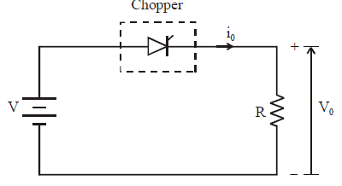
Fig.5.1 Step‐down Chopper with Resistive Load
The thyristor in the circuit acts as a switch. When thyristor is ON, supply voltage appears across the load and when thyristor is OFF, the voltage across the load will be zero. The output voltage and current waveforms are as shown in figure below.
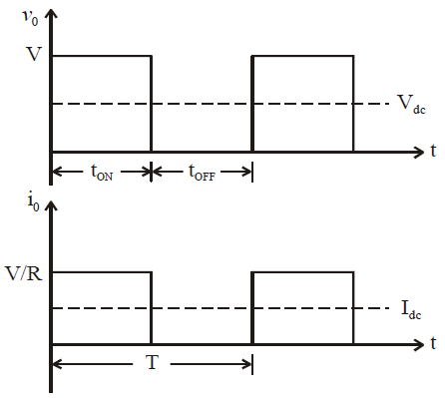
Fig.5.2 Step-down choppers — output voltage and current waveforms

Expression for Output Voltage
V_{dc}=average value of output or load voltage
I_{dc}=average value of output or load current
t_{ON} =time for which SCR is ON
t_{OFF} time interval for which SCR is OFF
T=t_{ON}+t_{OFF}=period of switching or chopping period
f=1/T=frequency pf chopper switching or chopper frequency
Average output voltage
V_{dc}=V(t_{on}/t_{on}+t_{off})
V_{dc}=V(ton/T)=Vd
But (t_{ON}/T)=d=duty cycle
Average output current Idc=Vdc/r
Idc=(v/r)d
RMS value of output voltage
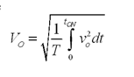
But during T_{on} Vo=V
Therefore RMSoutput voltage Vo=
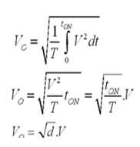
Output power P_{o}=V_{o}I_{o}
But Io=Vo/R
Therefore P_{o}=V_{o}²/R
P_{o}=dV²/R
Effective input resistance R_{i}=V/I_{dc}
R_{i}=R/d
The output voltage can be varied by varying duty cycle
Principle of Step Up Chopper

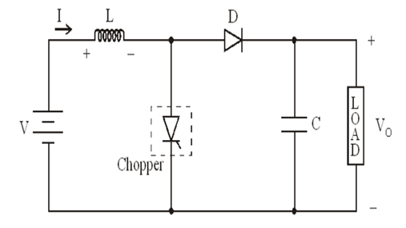
Fig.5.3 Step up chopper
Above figure, shows a step-up chopper to obtain a load voltage Vo higher than the input voltage V.The values of L and C are chosen depending upon the requirement of output voltage and current .When the chopper is ON, the inductor L is connected across the supply.The inductor current I rises and the inductor stores energy during the ON time of the chopper,I_{ON.}When the chopper is off ,the inductor current I is forced to flow through the diode D and load for a period ,t_{OFF .}The current tends to decrease resulting in reversing the polarity of induced EMF in L.Therefore voltage across load is given by
V_{o}=V+Ldi/dt i.e., V_{o}>V
Expression For Output Voltage
Assume the average inductor current to be I during ON and OFF time of the chopper
When chopper is on
Voltage across inductor L=V
Therefore energy stored in inductor = V.I.t_{ON}
Where T_{ON} =ON period of chopper
When Chopper is OFF (energy is supplied by inductor to load)
Voltage across L=(V_{o-}V)It_{OFF} ,Where t_{OFF} =OFF period of chopper.
Neglecting losses,energy stored in inductor L=energy supplied by inductor L
Therefore
VIt_{ON} =(V_{o-}V)It_{OFF}
V_{o}=V[T_{ON}+T_{OFF}]/T_{OFF}
V_{o}=V(T/T-t_{ON})
Where T=Chopping period or period of switch T=t_{On}+t_{OFF}
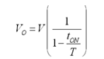

VI.PULSE WIDTH MODULATION AND CONTROLLER

6.1 Pulse Width Modulation
Pulse Width Modulation (PWM) is the most effective means to achieve constant voltage battery charging by switching the solar system controller’s power devices. When in PWM regulation, the current from the solar array tapers according to the battery’s condition and recharging needs a consider waveform such as this: it is a voltage switching between 0v and 12v. It is fairly obvious that, since the voltage is at 12v for exactly as long as it is at 0v, then a 'suitable device' connected to its output will see the average voltage and think it is being fed 6v - exactly half of 12v. So by varying the width of the positive pulse - we can vary the 'average' voltage.
Similarly, if the switches keep the voltage at 12 for 3 times as long as at 0v, the average will be 3/4 of 12v - or 9v, as shown below and if the output pulse of 12v lasts only 25% of the overall time, then the average is
By varying - or 'modulating' - the time that the output is at 12v (i.e. the width of the positive pulse) we can alter the average voltage. So we are doing 'pulse width modulation'. I said earlier that the output had to feed 'a suitable device'. A radio would not work from this: the radio would see 12v then 0v, and would probably not work properly. However a device such as a motor will respond to the average, so PWM is a natural for motor control. Pulse Width modulator
So, how do we generate a PWM waveform? It's actually very easy, there are circuits available in the TEC site. First you generate a triangle waveform as shown in the diagram below. You compare this with a d.c voltage, which you adjust to control the ratio of on to off time that you require. When the triangle is above the 'demand' voltage, the output goes high. When the triangle is below the demand voltage, the
When the demand speed it in the middle (A) you get a 50:50 output, as in black. Half the time the output is high and half the time it is low. Fortunately, there is an IC (Integrated circuit) called a comparator: these come usually 4 sections in a single package. One can be used as the oscillator to produce the triangular waveform and another to do the comparing, so a complete oscillator and modulator can be done with half an IC and maybe 7 other bits.
The triangle waveform, which has approximately equal rise and fall slopes, is one of the commonest used, but you can use a saw tooth (where the voltage falls quickly and rinses slowly). You could use other waveforms and the exact linearity (how good the rise and fall are) is not too important.
Traditional solenoid driver electronics rely on linear control, which is the application of a constant voltage across a resistance to produce an output current that is directly proportional to the voltage. Feedback can be used to achieve an output that matches exactly the control signal. However, this scheme dissipates a lot of power as heat, and it is therefore very inefficient.
A more efficient technique employs pulse width modulation (PWM) to produce the constant current through the coil. A PWM signal is not constant. Rather, the signal is on for part of its period, and off for the rest. The duty cycle, D, refers to the percentage of the period for which the signal is on. The duty cycle can be anywhere from 0, the signal is always off, to 1, where the signal is constantly on. A 50% D results in a perfect square wave.
A solenoid is a length of wire wound in a coil. Because of this configuration, the solenoid has, in addition to its resistance, R, a certain inductance, L. When a voltage V, is applied across an inductive element, the current I, produced in that element does not jump up to its constant value, but gradually rises to its maximum over a period of time called the rise time . Conversely, I does not disappear instantaneously, even if V is removed abruptly, but decreases back to zero in the same amount of time as the rise time.
Therefore, when a low frequency PWM voltage is applied across a solenoid, the current through it will be increasing and decreasing as V turns on and off. If D is shorter than the rise time, I will never achieve its maximum value, and will be discontinuous since it will go back to zero during V’s off period . In contrast, if D is larger than the rise time, I will never fall back to zero, so it will be continuous, and have a DC average value. The current will not be constant, however, but will have a ripple.
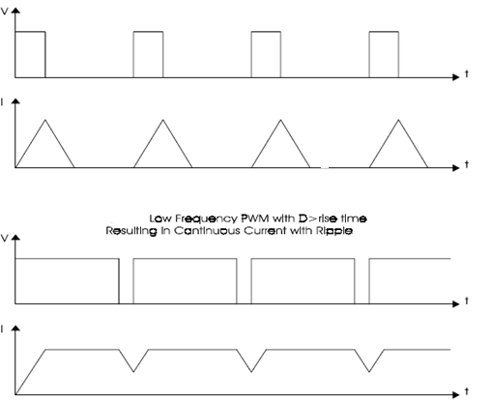
At high frequencies, V turns on and off very quickly, regardless of D, such that the current does not have time to decrease very far before the voltage is turned back on. The resulting current through the solenoid is therefore considered to be constant. By adjusting the D, the amount of output current can be controlled. With a small D, the current will not have much time to rise before the high frequency PWM voltage takes effect and the current stays constant. With a large D, the current will be able to rise higher before it becomes constant.
Why the PWM Frequency is important?
The PWM is a large amplitude digital signal that swings from one voltage extreme to the other. And, this wide voltage swing takes a lot of filtering to smooth out. When the PWM frequency is close to the frequency of the waveform that you are generating, then any PWM filter will also smooth out your generated waveform and drastically reduce its amplitude. So, a good rule of thumb is to keep the PWM frequency much higher than the frequency of any waveform you generate.
Finally, filtering pulses is not just about the pulse frequency but about the duty cycle and how much energy is in the pulse. The same filter will do better on a low or high duty cycle pulse compared to a 50% duty cycle pulse. Because the wider pulse has more time to integrate to a stable filter voltage and the smaller pulse has less time to disturb it the inspiration was a request to control the speed of a large positive displacement fuel pump. The pump was sized to allow full power of a boosted engine in excess of 600 Hp.At idle or highway cruise, this same engine needs far less fuel yet the pump still normally supplies the same amount of fuel. As a result the fuel gets recycled back to the fuel tank, unnecessarily heating the fuel. This PWM controller circuit is intended to run the pump at a low speed setting during low power and allow full pump speed when needed at high engine power levels.
PWM Controller Features
This controller offers a basic “Hi Speed” and “Low Speed” setting and has the option to use a “Progressive” increase between Low and Hi speed. Low Speed is set with a trim pot inside the controller box. Normally when installing the controller, this speed will be set depending on the minimum speed/load needed for the motor. Normally the controller keeps the motor at this Lo Speed except when Progressive is used and when Hi Speed is commanded (see below). Low Speed can vary anywhere from 0% PWM to 100%.
Progressive control is commanded by a 0-5 volt input signal. This starts to increase PWM% from the low speed setting as the 0-5 volt signal climbs. This signal can be generated from a throttle position sensor, a Mass Air Flow sensor, a Manifold Absolute Pressure sensor or any other way the user wants to create a 0-5 volt signal. This function could be set to increase fuel pump power as turbo boost starts to climb (MAP sensor). Or, if controlling a water injection pump, Low Speed could be set at zero PWM% and as the TPS signal climbs it could increase PWM%, effectively increasing water flow to the engine as engine load increases.
This controller could even be used as a secondary injector driver (several injectors could be driven in a batch mode, hi impedance only), with Progressive control (0-100%) you could control their output for fuel or water with the 0-5 volt signal.
Progressive control adds enormous flexibility to the use of this controller. Hi Speed is that same as hard wiring the motor to a steady 12 volt DC source. The controller is providing 100% PWM, steady 12 volt DC power. Hi Speed is selected three different ways on this controller: 1) Hi Speed is automatically selected for about one second when power goes on. This gives the motor full torque at the start. If needed this time can be increased (the value of C1 would need to be increased). 2) High Speed can also be selected by applying 12 volts to the High Speed signal wire. This gives Hi Speed regardless of the Progressive signal.
6.2 Sinusoidal Pulse Width Modulation
In many industrial applications, Sinusoidal Pulse Width Modulation (SPWM), also called Sine coded Pulse Width Modulation, is used to control the inverter output voltage. SPWM maintains good performance of the drive in the entire range of operation between zero and 78 percent of the value that would be reached by square-wave operation. If the modulation index exceeds this value, linear relationship between modulation index and output voltage is not maintained and the over-modulation methods are required.

6.3 Space Vector Pulse Width Modulation
A different approach to SPWM is based on the space vector representation of voltages in the d, q plane. The d, q components are found by Park transform, where the total power, as well as the impedance, remains unchanged.
Fig: space vector shows 8 space vectors in according to 8 switching positions of inverter, V* is the phase-to-center voltage which is obtained by proper selection of adjacent vectors V1 and V2.
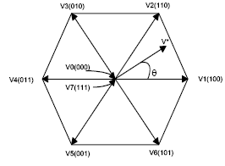
Inverter output voltage space vector
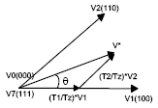
Fig.6.1 Determination of Switching times
The reference space vector V* is given by Equation (1), where T1, T2 are the intervals of application of vector V1 and V2 respectively, and zero vectors V0 and V7 are selected for T0.
V* Tz = V1 *T1 + V2 *T2 + V0 *(T0/2) + V7 *(T0/2)
Figure.6.2 below shows that the inverter switching state for the period T1 for vector V1 and for vector V2, resulting switching patterns of each phase of inverter are shown in Fig. pulse pattern of space vector PWM.
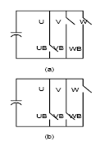
Fig.6.2 Inverter switching state for (a)V1 (b) V2
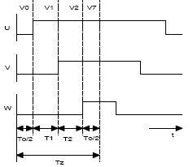
Fig.6.3Pulse pattern of Space vector PWM
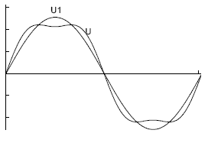
In Fig. comparison, U is the phase to- center voltage containing the triple order harmonics that are generated by space vector PWM, and U1 is the sinusoidal reference voltage. But the triple order harmonics are not appeared in the phase-to-phase voltage as well. This leads to the higher modulation index compared to the SPWM.
Comparison of SPWM and Space Vector PWM
As mentioned above, SPWM only reaches to 78 percent of square wave operation, but the amplitude of maximum possible voltage is 90 percent of square-wave in the case of space vector PWM. The maximum phase-to-center voltage by sinusoidal and space vector
PWM are respectively
Vmax = Vdc/2 Sinusoidal PWM
Vmax = Vdc/√3 Space Vector PWM
Where, Vdc is DC-Link voltage.
This means that Space Vector PWM can produce about 15 percent higher the Sinusoidal PWM in output voltage.
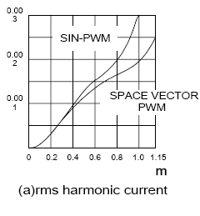
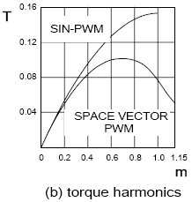

6.4 Two-Level PWM
The most common and popular technique of digital pure-sine wave generation is pulse-width-modulation (PWM). The PWM technique involves generation of a digital waveform, for which the duty-cycle is modulated such that the average voltage of the waveform corresponds to a pure sine wave. The simplest way of producing the PWM signal is through comparison of a low-power reference sine wave with a triangle wave using these two signals as input to a comparator, the output will be a 2-level PWM signal . This PWM signal can then be used to control switches connected to a high-voltage bus, which will replicate this signal at the appropriate voltage. Put through an LC filter, this PWM signal will clean up into a close approximation of a sine wave . Though this technique produces a much cleaner source of AC power than either the square or modified sine waves, the frequency analysis shows that the primary harmonic is still truncated, and there is a relatively high amount of higher level harmonics in the signal
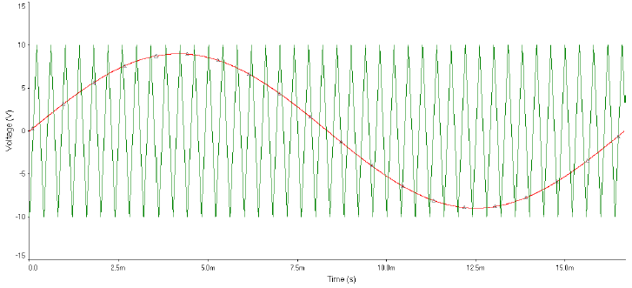
Fig.6.4 Two Level PWM Comparison Signals
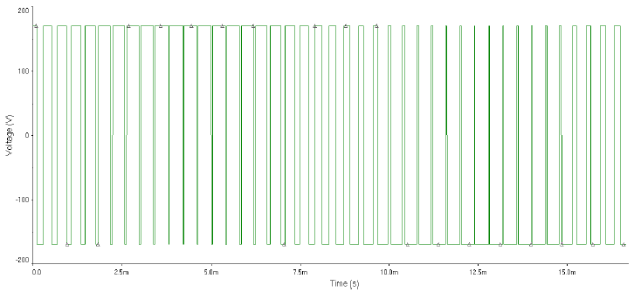
Fig.6.5 Two Level PWM Output (Unfiltered)
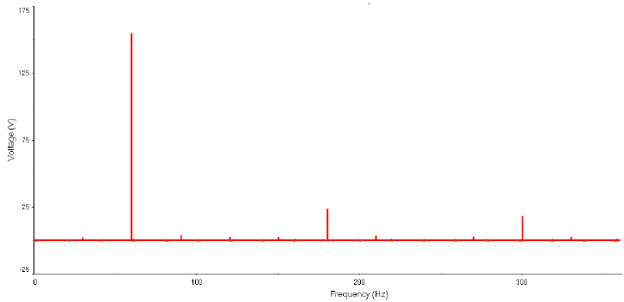
Fig.6.6 Two Level PWM Harmonic Analysis
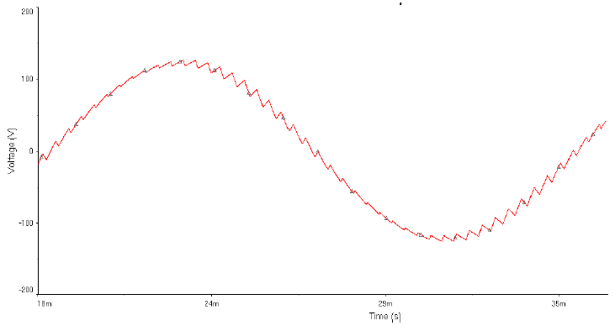
Fig.6.7 Two Level PWM Output (Filtered)
6.5 Three-Level PWM
In order to create a signal which is closer to a true sine wave, a 3 level PWM signal can be generated with high, low, and zero voltage levels. For the resulting 3-level PWM signal to correspond to a sine wave, the signal comparison stage must also be 3-level. A triangle wave is used as it is in the 2-level PWM comparison, but it half the amplitude and summed with a square wave to compare one half of the sine reference signal at a time. The resulting PWM signal is used to control one half of an H-bridge, which controls how long the bus voltage is allowed through to the load. The other half of the H-bridge controls the polarity of the voltage across the load, and is controlled by a simple square wave of the same frequency and in phase with the sine signal. Generally, this square wave can simply be created in a stage of the sine wave generation circuit. A virtual example of such a 3-level circuit we simulated is shown in. The resulting 3-level high-voltage PWM signal can be filtered into a very close approximation of the desired sine wave . It should be noted that the simulations we did for this technique utilized a very low switching frequency for the triangle wave, so the PWM switching frequency is also low. This was done so that the waveforms would be easy to view and understand. In reality, a switching frequency above 20 kHz would be used to keep inductance ringing outside the range of human hearing.
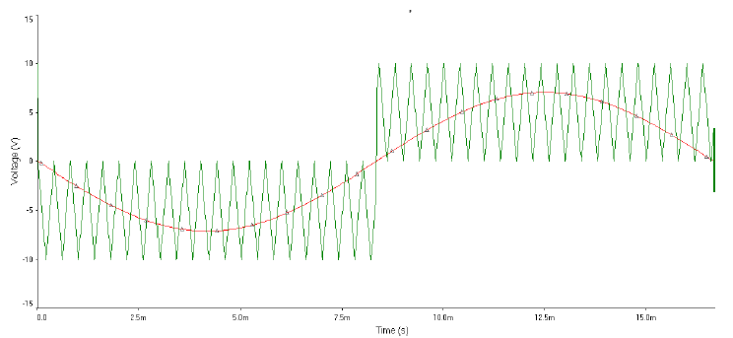
Fig.6.8 Three Level PWM Comparison Control Signals
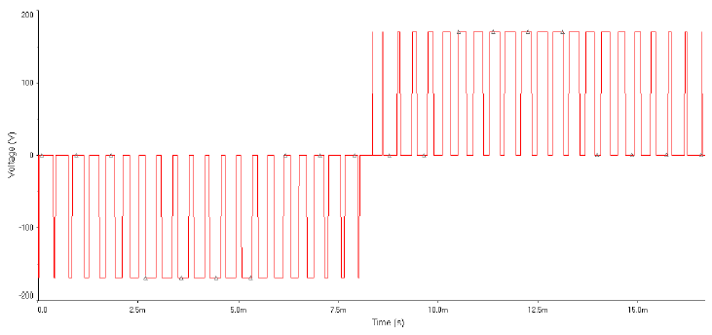
Fig.6.9 Simulated 3-Level PWM Output (Unfiltered)
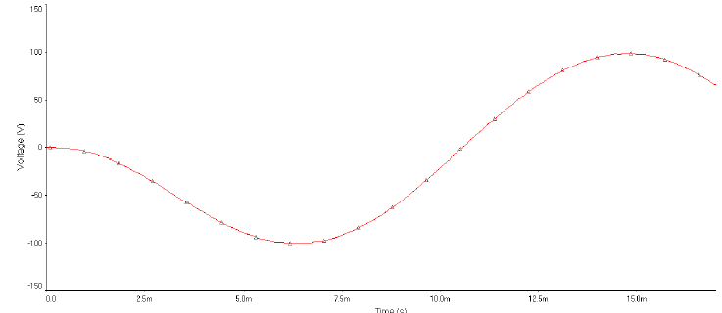
Fig.6.10 Simulated 3-Level PWM Output (Filtered)
Fig.6.11 Three PWM Harmonics Analysis of Unfiltered Output
The 3-Level PWM frequency plot shown in figure marked improved over those of the square and modified sine techniques. The primary frequency of 60Hz is the dominant in all three, but the magnitude of the harmonic frequencies is much reduced in 3-Level PWM, and the primary is of larger magnitude. When compared to the 2-level PWM, however, a couple things are noticed. First, the harmonics plot shows no higher level harmonics of significant magnitude. This represents the 3-Level signal following much more closely the desired sine wave. However, the primary frequency has a much lower voltage magnitude than that of the 2-Level design. The reason for this is the presence of other frequencies which are not harmonics of the 60Hz signal, which are caused by the switching of the signal from one polarity to the other, and back.
6.6 Five-Level PWM
In order to create a PWM signal which more closely follows the desired sine wave output, the design described for the 3-level PWM technique can be expanded to 5-, 7- and 9+ level PWM. Each additional 2 levels added on top of the 3-level design adds an H-bridge (added in series), a comparator, and a summer. The added accuracy of the signal due to increasing the level therefore brings with it the addition of components, and the space, cooling, and power they require. Control signals must be created separately for each H-bridge ,each of which correspond to one layer of the sine voltage . Higher level PWM also requires multiple isolated voltage buses. The buses must be isolated, as they need to be connected in series. In the 5-level PWM circuit, one half of each H-bridge is controlled by the square wave from the 3-level circuit, and simply controls polarity across the bridge. The other half of each bridge is controlled by the PWM output of each respective comparator. The resulting PWM signal is shown in fig.6.10, and the filtered sine wave output is shown in fig.6.11. One of the advantages of higher level PWM generation is that there is less of a voltage swing from the minimum and maximum of each step, which results in less power loss due to the slope up and down for each step (known as dV/dt losses). This reduced power loss results in higher efficiency for the inverter. This increased efficiency must be considered in balance with the addition of components and frequency effects which must be filtered out.
The harmonic frequencies are reduced, as in the 3-level technique, but the magnitude of the primary is significantly larger. Note that these plots show only harmonics of the 60Hz primary, and thus do not show the effects of the switching frequencies. The improvement of the 5-level PWM can, however, still be seen in the difference of the primary frequency's magnitude
Fig.6.12 Five Level PWM Comparison Signals
Fig 6.13 Five Level PWM Bridge Control Signals (superimposed)
Fig.6.14 Five Level PWM Output (unfiltered)
Fig.6.15 Five Level PWM Output (filtered)
Fig.6.16 Five Level PWM Harmonics Analysis of Unfiltered Output
6.7 Controllers
PI Controller
A PI Controller (proportional-integral controller) is a special case of the PID controller in which the derivative (D) of the error is not used. The controller output is given by
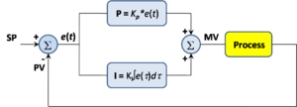
Fig.6.17 Block Diagram of PI Controller
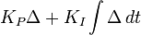
where is the error or deviation of actual measured value (PV) from the set point (SP).
.
A PI controller can be modeled easily in software such as Simulink using a "flow chart" box involving Laplace operators:
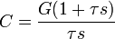
Where
= proportional gain
= integral gain
Setting a value for is often a tradeoff between decreasing overshoot and increasing settling time.
The lack of derivative action may make the system steadier in the steady state in the case of noisy data. This is because derivative action is more sensitive to higher-frequency terms in the inputs. Without derivative action, a PI-controlled system is less responsive to real (non-noise) and relatively fast alterations in state and so the system will be slower to reach set point and slower to respond to perturbations than a well-tuned PID system

PID Controller
A proportional-integral-derivative-controller (PIDcontroller)widely used in the industrial control systems. A PID controller calculates an "error" value as the difference between a measured value and a desired set point. The controller attempts to minimize the error by adjusting the process control inputs.
The PID controller calculation algorithm involves three separate constant parameters, and is accordingly sometimes called three-term control: the Proportional, integral and derivative values, denoted P, I, and D. Then these values can be interpreted in terms of time: P depends on the present error, I on the accumulation of past errors, and D is a prediction of future errors, based on current rate of change. The weighted sum of these three actions is used to adjust the process via a control element such as the position of a control valve, a damper, or the power supplied to a heating element.
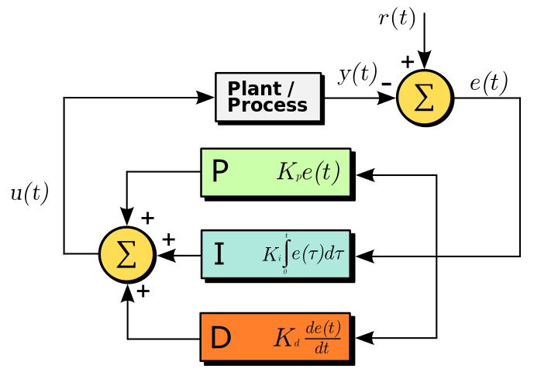
Fig6.18 Block diagram of a PID controller
The PID control scheme is named after its three correcting terms, whose sum constitutes the manipulated variable (MV). The proportional, integral, and derivative terms are summed to calculate the output of the PID controller. Defining as the controller output, the final form of the PID algorithm is:
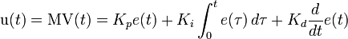
where
: Proportional gain, a tuning parameter
: Integral gain, a tuning parameter
: Derivative gain, a tuning parameter
: Error
: Time or instantaneous time (the present)
- : Variable of integration; takes on values from time 0 to the present.

Proportional term
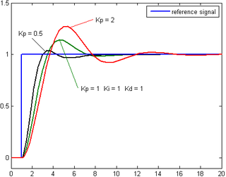
Fig6.19 Plot of PV VS time, for three values of K_{p} (K_{i} and K_{d} held constant)
The proportional term produces an output value that is proportional to the current error value. The proportional response can be adjusted by multiplying the error by a constant K_{p}, called the proportional gain constant.
The proportional term is given by:
6.8 Control System Algorithm And Implementation
The feedback controller used in this application utilizes the PID algorithm. As shown in Fig., the current injected into the grid, also known as grid current Ig, is sensed and fed back to a comparator which compares it with the reference current Iref . Iref is obtained by sensing the grid voltage and converting it to reference current and multiplying it with constant m. This is to ensure that Ig is in phase with grid voltage Vg and always at near-unity power factor. One of the problems in the PV generation systems is the amount of the electric power generated by solar arrays always changing with weather conditions, i.e., the intensity of the solar radiation. A maximum power point tracking (MPPT) method or algorithm, which has quick-response characteristics and is able to make good use of the electric power generated in any weather, is needed to solve the aforementioned problem. Constant m is derived from the MPPT algorithm.

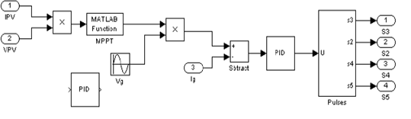
Fig.6.20. MPPT Technology

The perturb and observe algorithm is used to extract maximum power from PV arrays and deliver it to the inverter. The instantaneous current error is fed to a PID controller.The integral term in the PID controller improves the tracking by reducing the instantaneous error between the reference and the actual current. The resulting error signal u which formsVref1 and Vref2 is compared with a triangular carrier signal and intersections are sought to produce PWM signals for the inverter switches. Implementing this algorithm using a DSP requires one to transform it into the discrete time domain. Trapezoidal sum approximation is used to transform the integral term into the discrete time domain because it is the most straightforward technique. The proportional term is directly used without approximation.

VII. SIMULATION RESULTS
BLOCK DIAGRAM
Fig.7.0 Simulink Diagram for five level inverter

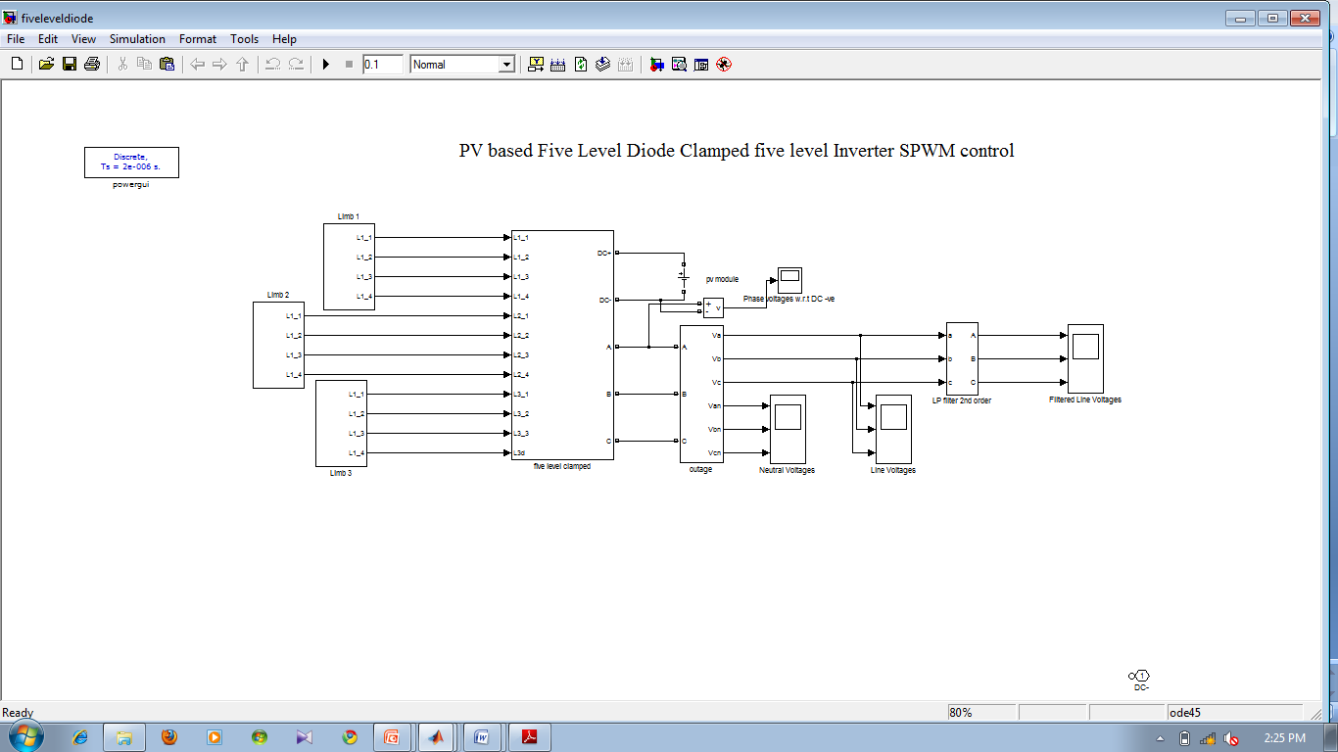
Fig.7.1 PV based Five level Diode clamped inverter SPWM control
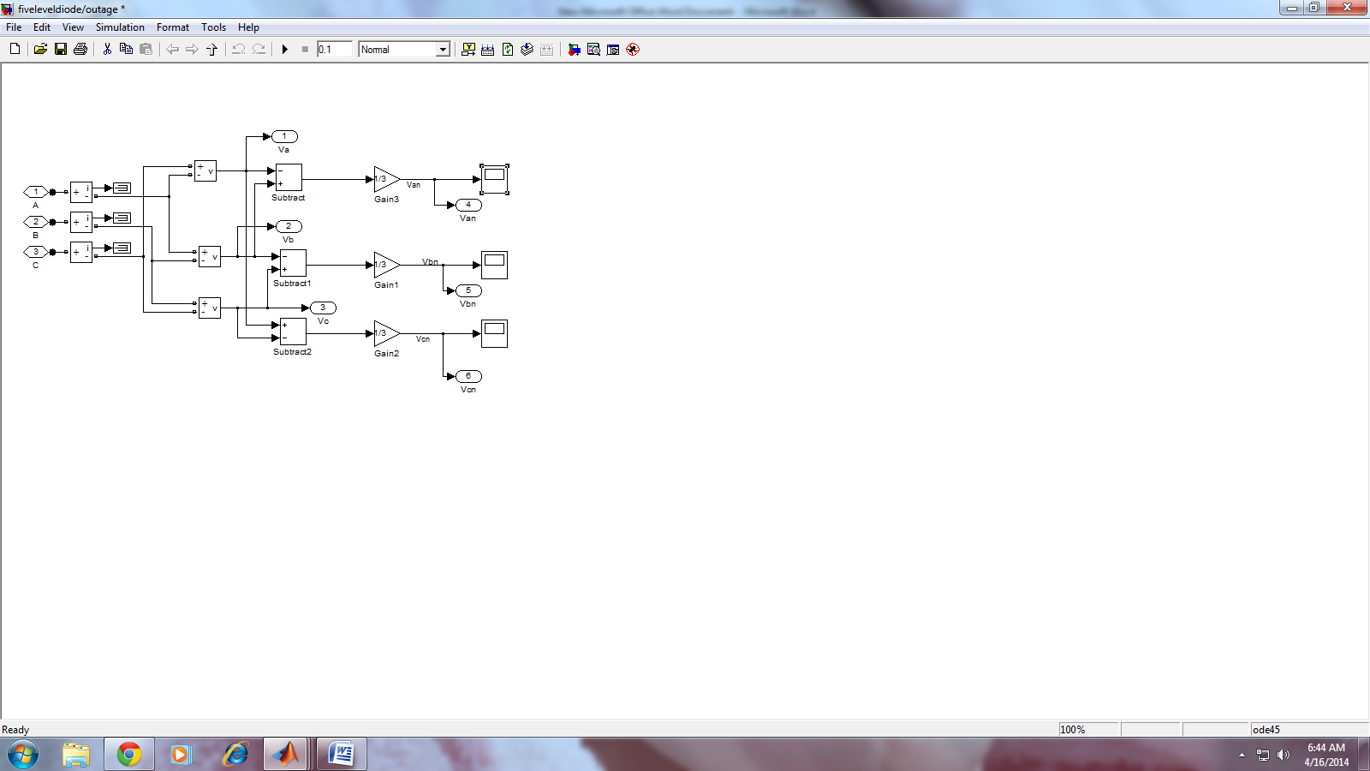
Fig.7.2 Five level Diode clamped outage
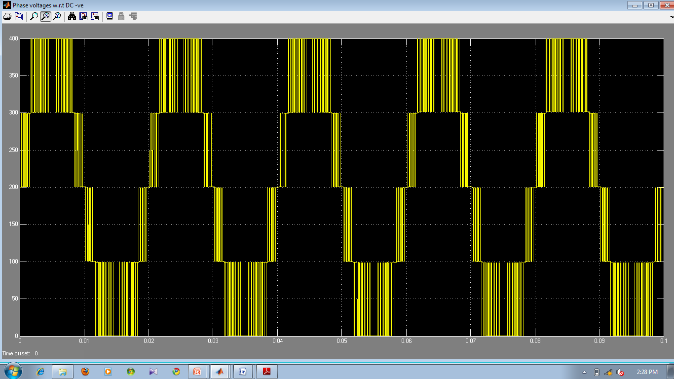
Fig.7.3 Phase voltages with respect to DC
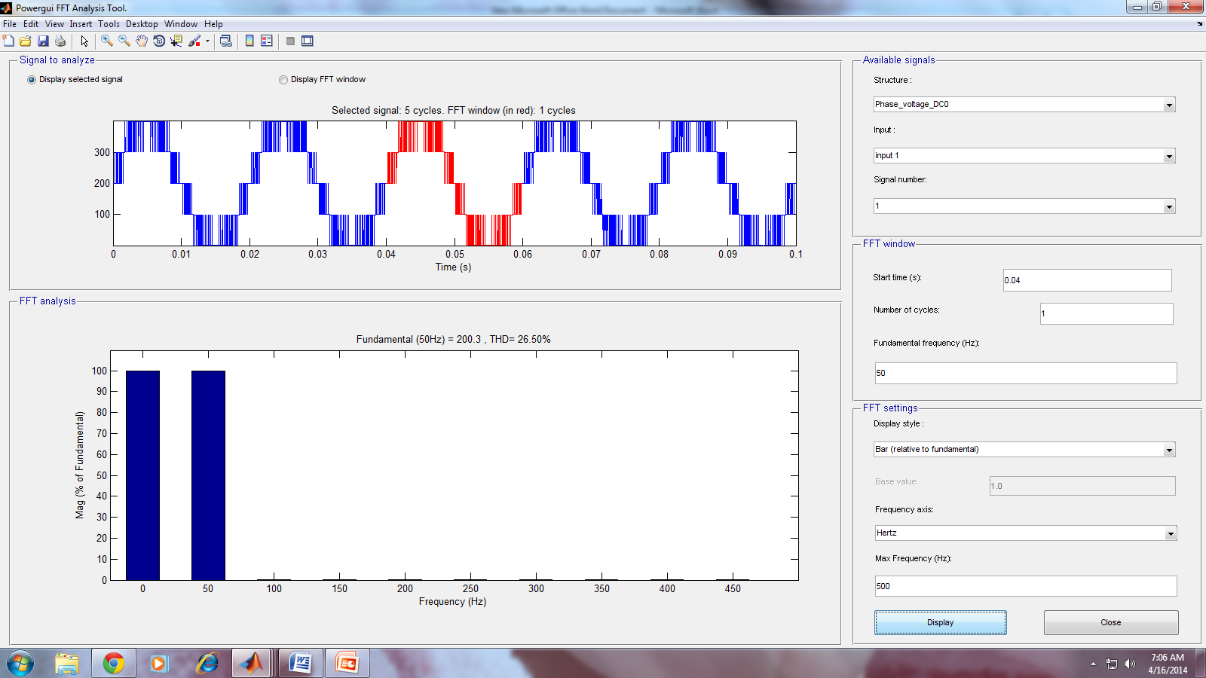
Fig.7.4THD values of Phase voltages

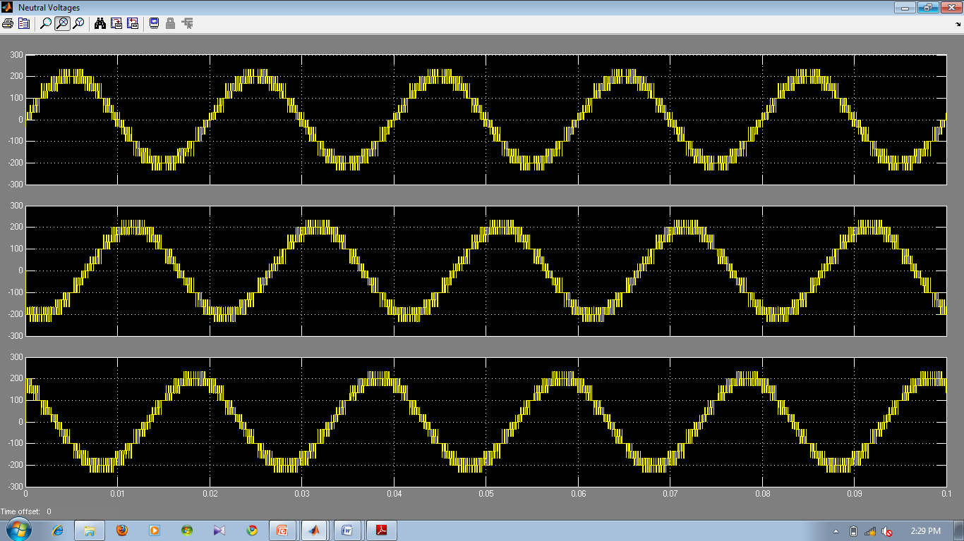
Fig.7.5 Neutral voltages

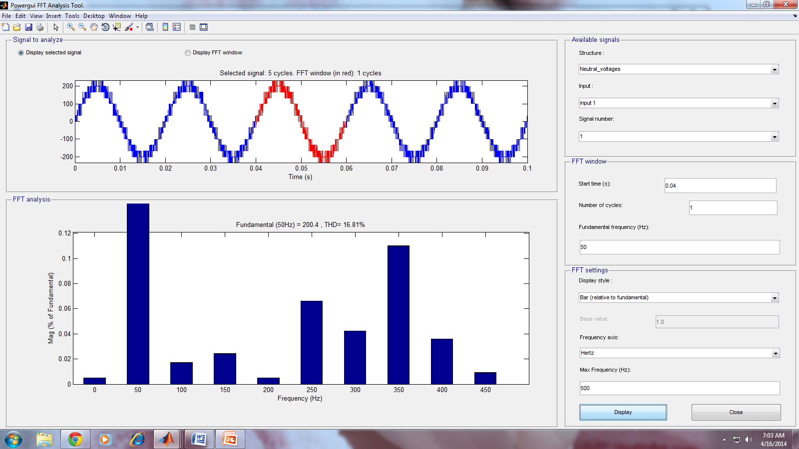
Fig.7.6 THD values of Neutral voltages

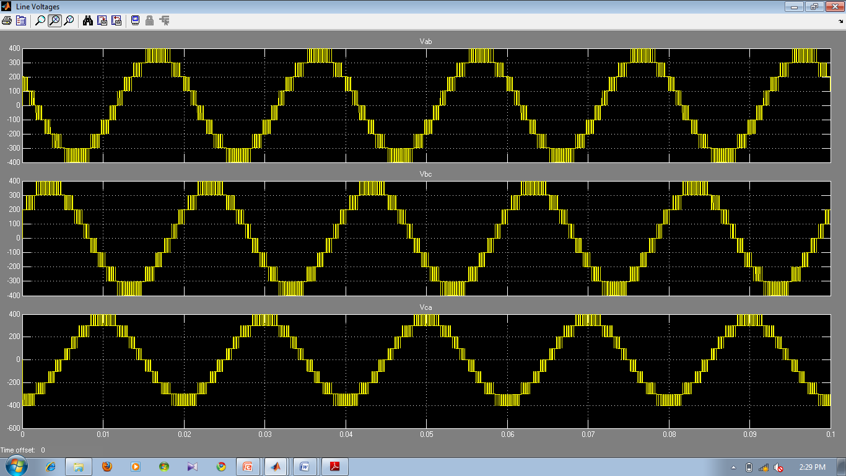
Fig.7.7 Line voltages

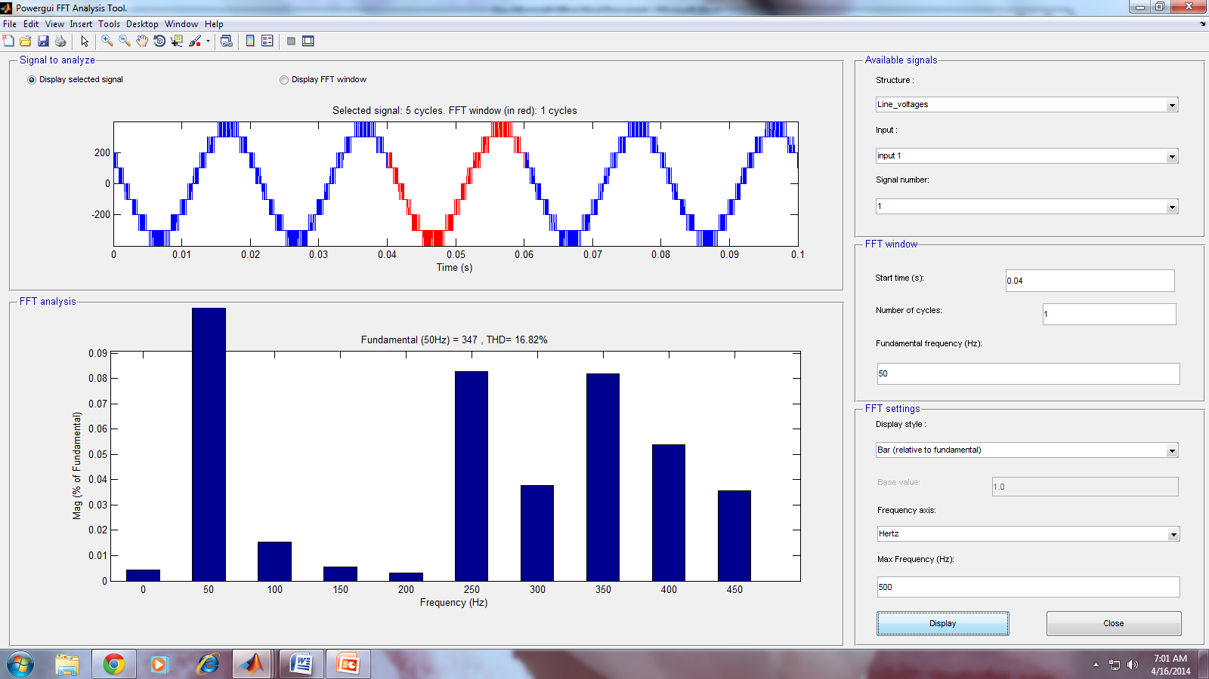
Fig.7.8 THD Values of Line Voltages

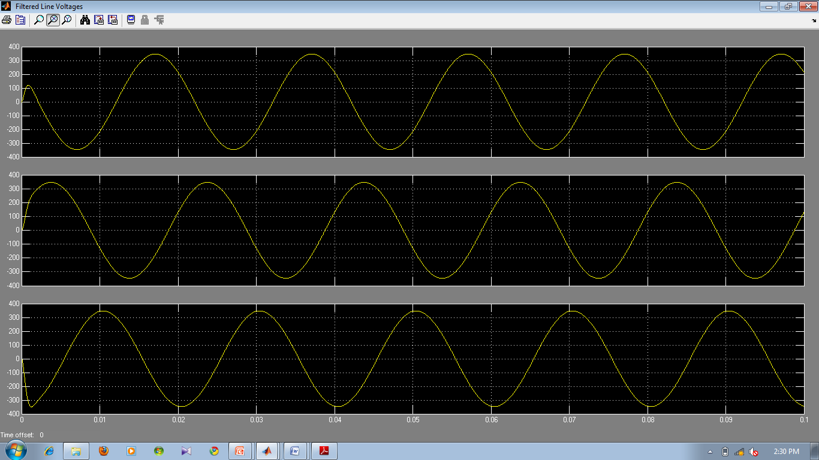
Fig.7.9 Filtered line voltages

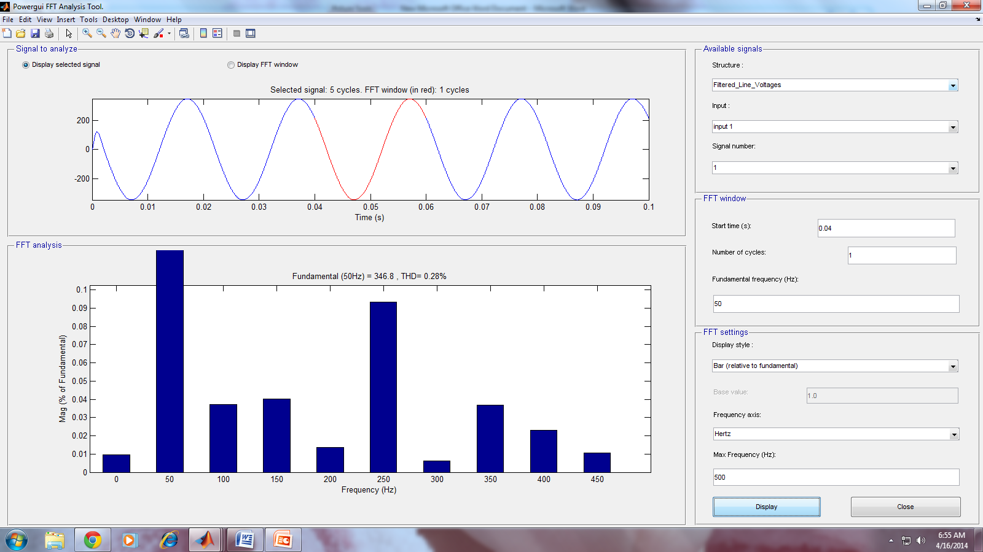
Fig.7.10 THD Values of Filtered Line Voltages

VIII.CONCLUSION
In the field of high power, high performance applications the multi-level inverters seem to be the most promising alternative. In multilevel inverters, as the switching involves several small voltages, the rapid change in voltage is smaller. Further, switching at the fundamental frequency will also result in decreasing the number of times these voltage changes occur per fundamental cycle. But harmonic elimination is the major issue for multilevel inverters.
The results have been presented and analyzed. On the other hand from the results, it is observed that as the modulation index is increased the total harmonic distortion (THD) decreases and also the fundamental RMS value increases linearly. By using this method, the results obtained for THD in two-level and three-level inverters are 54.02% and 28.60% respectively. But the level of inverter increases, the complexity of control algorithm and execution time increases. From the results, it is observed that the inverter performance is highly improved. The output voltage total harmonic distortion for three-level and five-level inverters is 5.7% and 3.61% respectively. The total harmonic distortion (THD) is highly reduced as the level of inverter is increased. From the above analysis, the total harmonic distortion (THD) with the proposed method for two-level, three-level, four-level, five-level inverters are 42.48%, 24.99%, 17.05%, and 11.57% respectively.

BIBLIOGRAPHY
- J. M. Carrasco, L. G. Franquelo, J. T. Bialasiewicz,E.Galvan,R.C.PortilloGuisado, M. A. M. Prats, J. I. Leon, and N.Moreno-Alfonso, “Power-electronic systems for the grid integration of renewable energy sources: A survey,” IEEE Trans. Ind. Electron., vol. 53, no. 4, pp. 1002–1016, Aug. 2006

- V. G. Agelidis D. M. Baker, W. B. Lawrance, and C. V. Nayar, “A mZZZultilevel PWM inverter topology for photovoltaic applications,” in Proc. IEEE ISIE, Guimarães, Portugal, 1997, pp. 589–594

- S. Kouro, J. Rebolledo, and J. Rodriguez, “Reduced switching-frequency modulation algorithm for high-power multilevel inverters,” IEEE Trans. Ind. SElectron., vol. 54, no. 5, pp. 2894–2901, Oct. 2007.

- S. J. Park, F. S. Kang, M. H. Lee, and C. U. Kim, “A new single-phase five level PWM inverter employing a deadbeat control scheme,” IEEE Trans. Power Electron., vol. 18, no. 18, pp. 831–843, May 2003.

- L. M. Tolbert and T. G. Habetler, “Novel multilevel inverter carrier-based PWM method,” IEEE Trans. Ind. Appl., vol. 35, no. 5, pp. 1098–1107,Sep./Oct. 1999

